**HOP ON THE MERRY-GO-ROUND 3**

**Name:** ………………………………………………………….. **Class:** ………………

**1. Write the words.**

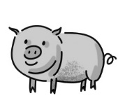**1. pig 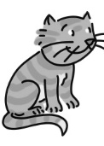 2. c_ _ 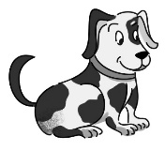 3. d_ _**

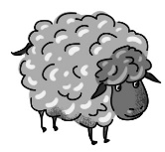**4. s_ _ _ _ 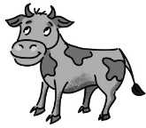 5. c_ _ 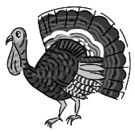 6. t_ _ _ _ _**

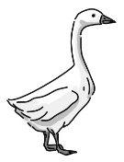 **7. g_ _ _ _ 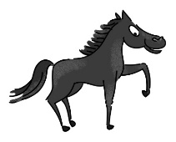8 . h_ _ _ _ 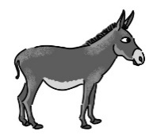9. d_ _ _ _ _**

**2. Fill in.**

• ride • man • great • cute • pet • ~~close~~

**1.** **Close** your eyes.

**2.** I can’t ………… a horse.

**3.** Simon hasn’t got a ………… .

**4.** That’s a ………… idea!

**5.** Chan’s kitten is so ………… .

**6.** Who is that …………?

**3. Write sentences.**

**1.** got ⬩ Chan ⬩ has ⬩ a ⬩ kitten .

**Chan has got a kitten.**

**2.** have ⬩ two ⬩ They ⬩ dogs ⬩ got .

……………………………………………………..………….

**3.** your ⬩ Has ⬩ friend ⬩ a ⬩ got ⬩ pet ?

……………………………………………………..………….

**4.** see ⬩ the ⬩ Can ⬩ tarantula ⬩ I ?

……………………………………………………..………….

**5.** cat ⬩ lazy ⬩ Granny’s ⬩ so ⬩ is .

……………………………………………………..………….

**6.** grandparents ⬩ have ⬩ a ⬩ farm ⬩ got ⬩ Simon’s .

……………………………………………………..………….

**4. Write** *have got* **or** *has got*.

**1.**Simon **has got** a horse.

**2.** Mr Sporty ……………… a dog.

**3.** We ……………… English today.

**4.** My aunt ……………… two parrots.

**5.** Jimmy and Robin ……………… new bikes.

**6.** My friends ……………… sandwiches for lunch.

     





**HOP ON THE MERRY-GO-ROUND 3**

**Name:** ………………………………………………………….. **Class:** ………………

**1. Write the words.**

**1. pig  2. c_ _  3. d_ _**

**4. s_ _ _ _  5. c_ _  6. t_ _ _ _ _**

** 7. g_ _ _ _ 8 . h_ _ _ _ 9. d_ _ _ _ _**

**2. Fill in. Be careful – there is an extra word!**

• ride • man • present • great • cute • animals • forehead • pet • ~~close~~

**1.** **Close** your eyes.

**2.** I can’t ………………… a horse.

**3.** Simon hasn’t got a ………………… .

**4.** That’s a …………………. idea!

**5.** Chan’s kitten is so ………………. .

**6.** Who is that ………………..?

**7.** Can we see the …………………………?

**8.** This budgie is a …………………. for my brother.

**3. Write sentences.**

**1.** got ⬩ Chan ⬩ has ⬩ a ⬩ kitten .

**Chan has got a kitten.**

**2.** have ⬩ two ⬩ They ⬩ dogs ⬩ got .

……………………………………………………..………….

**3.** your ⬩ Has ⬩ friend ⬩ a ⬩ got ⬩ pet ?

……………………………………………………..………….

**4.** see ⬩ the ⬩ Can ⬩ tarantula ⬩ I ?

……………………………………………………..………….

**5.** cat ⬩ lazy ⬩ Granny’s ⬩ so ⬩ is .

……………………………………………………..………….

**6.** grandparents ⬩ have ⬩ a ⬩ farm ⬩ got ⬩ Simon’s .

……………………………………………………..………….

**4. Write** *a****,*** *an****,* or***the***.**

**1.** It’s **an** ice cream. It’s …… chocolate ice cream.

**2.** Have you got …… umbrella?

**3.** …… umbrella isn’t here!

**4.** I’ve got …… orange bike.

**5.** I can see …… dog.

**6.** …… dog has got …… black spot on its forehead.

**7.** I am taking …… photo now. It is for …… school magazine.

**5. Write** *have got* **or** *has got*.

**1.**Simon **has got** a horse.

**2.** Mr Sporty ……………… a dog.

**3.** We ……………… English today.

**4.** My aunt ……………… two parrots.

**5.** Jimmy and Robin ……………… new bikes.

**6.** My friends ……………… sandwiches for lunch.

**6. Write sentences.**

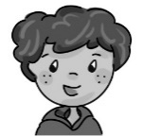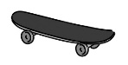

**1. He has got a skateboard.**

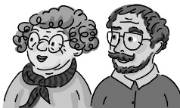 

**2.** …………………………………………………….

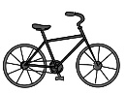 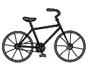

**3.** …………………………………………………….

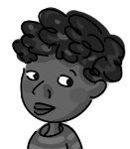 

**4.** …………………………………………………….

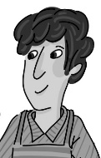 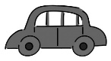

**5.** …………………………………………………….



**6.** …………………………………………………….

     